Jane's Fair Isle Tammy

by Blue Sheep Software

Size: AdultGauge: 24 rows and 24 stitches / 4" in stockinette.Materials:6 sport-weight yarns in the following colors:PurplePastel PinkAquamarinePersian GreenWisteriaPale Sky Blue5 double pointed needles in US size 3, or size to match gauge.Instructions:To knit the tammy hat, work the Hat chart 8 times in the round, using a stranded technique. For a tighter headband, use needles a size smaller on the ribbing. When complete, use a needle to thread the 16 remaining stitches with the yarn end, gather, and tie off. Weave in the loose ends. The hat can be stretched over a dinner plate for an evenly circular shape when blocking.

Hat
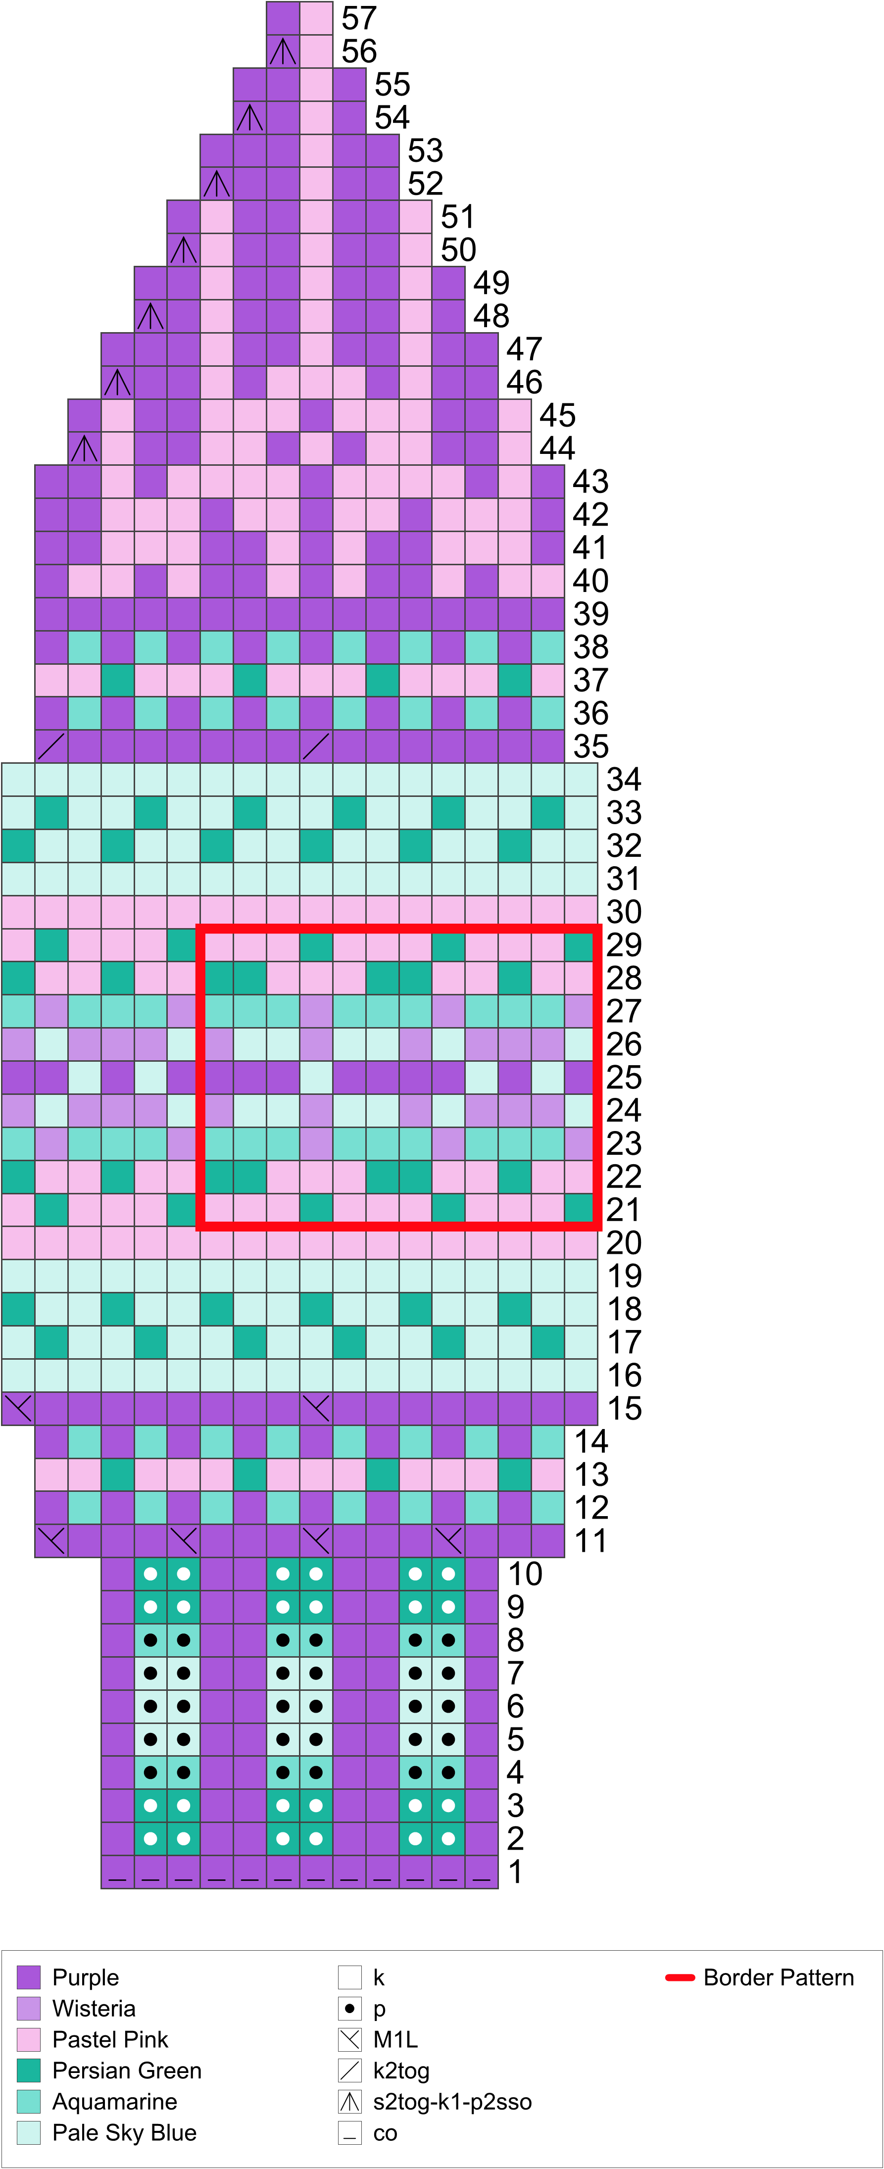

Round 1: Co 12 sts.
Rounds 2-10: K1, [p2, k2] twice, p2, k1.
Round 11: [K3, M1L] 4 times.
Rounds 12-14: K16.
Round 15: [K8, M1L] twice.
Rounds 16-34: K18.
Round 35: [K7, k2tog] twice.
Rounds 36-43: K16.
Round 44: K13, s2tog-k1-p2sso.
Round 45: K14.
Round 46: K11, s2tog-k1-p2sso.
Round 47: K12.
Round 48: K9, s2tog-k1-p2sso.
Round 49: K10.
Round 50: K7, s2tog-k1-p2sso.
Round 51: K8.
Round 52: K5, s2tog-k1-p2sso.
Round 53: K6.
Round 54: K3, s2tog-k1-p2sso.
Round 55: K4.
Round 56: K1, s2tog-k1-p2sso.
Round 57: K2.

Stitch Glossary

co
Cast on the specified number of stitches.

k
Knit.

k2tog
Knit 2 stitches together.

M1L
From the front, lift the horizontal strand between stitches with the left needle. Knit through the back loop.

p
Purl.

s2tog-k1-p2sso
Slip 2 stitches together knitwise, knit 1, then pass slipped stitches over.

